# CSS Styling Project Report

## Step 1. Create a CSS file

Created style.css and linked it to HTML pages using <link> tag.

Screenshot:

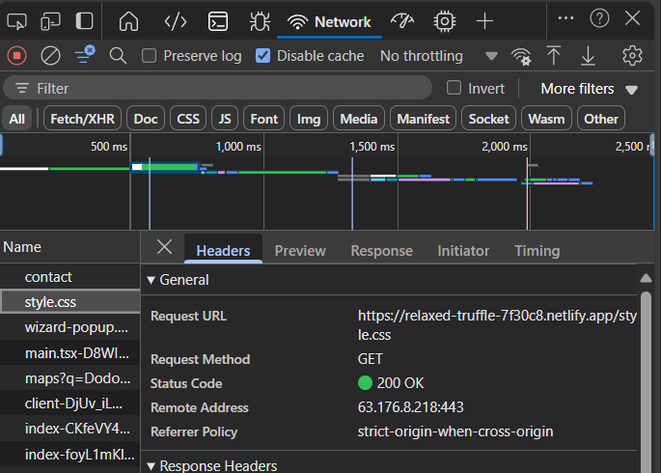

## Step 2. CSS Selectors

Applied element, class, ID, and descendant selectors.

Screenshot:

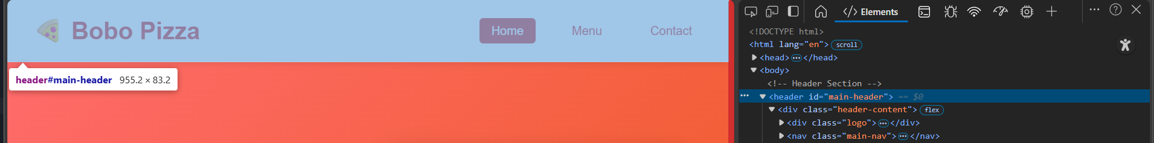

## Step 3. Typography

Changed font family, size, weight, alignment, and link styling with hover effects.

Screenshot:

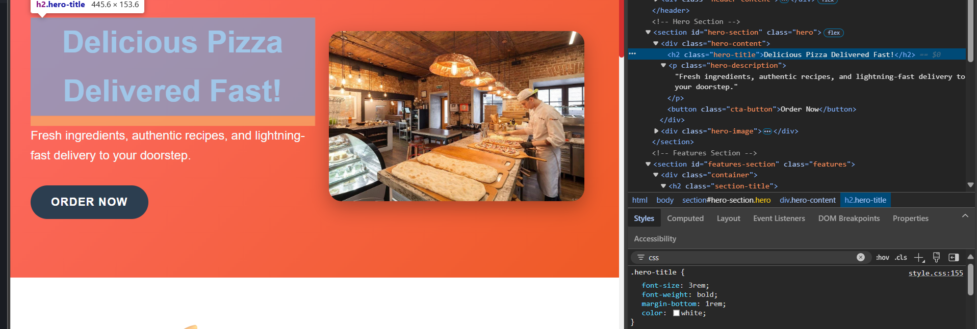

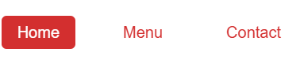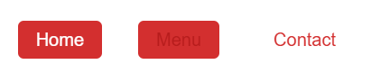

## Step 4. Colors and Backgrounds

Applied color scheme, background colors, and images.

Screenshot:

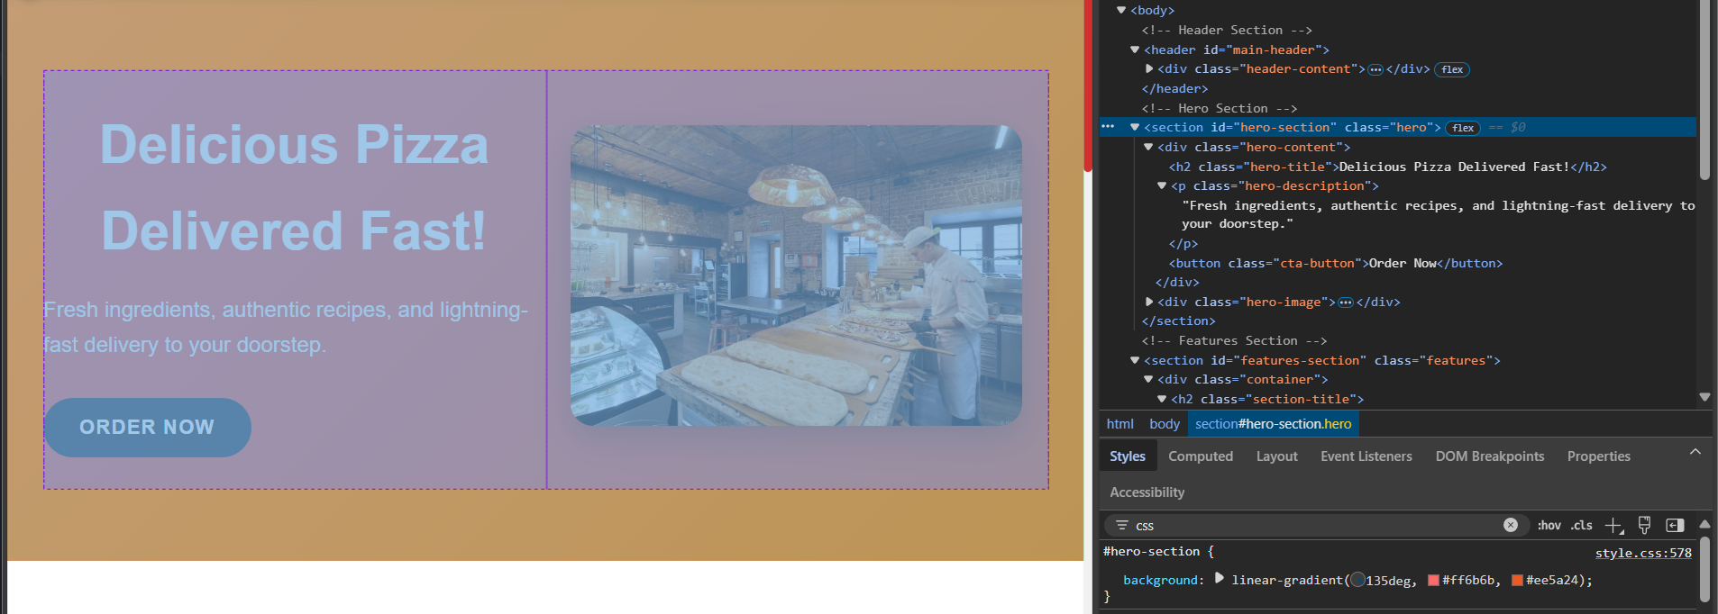

## Step 5. Layout and Box Model

Added margin, padding, border, width, and height adjustments.

Screenshot:

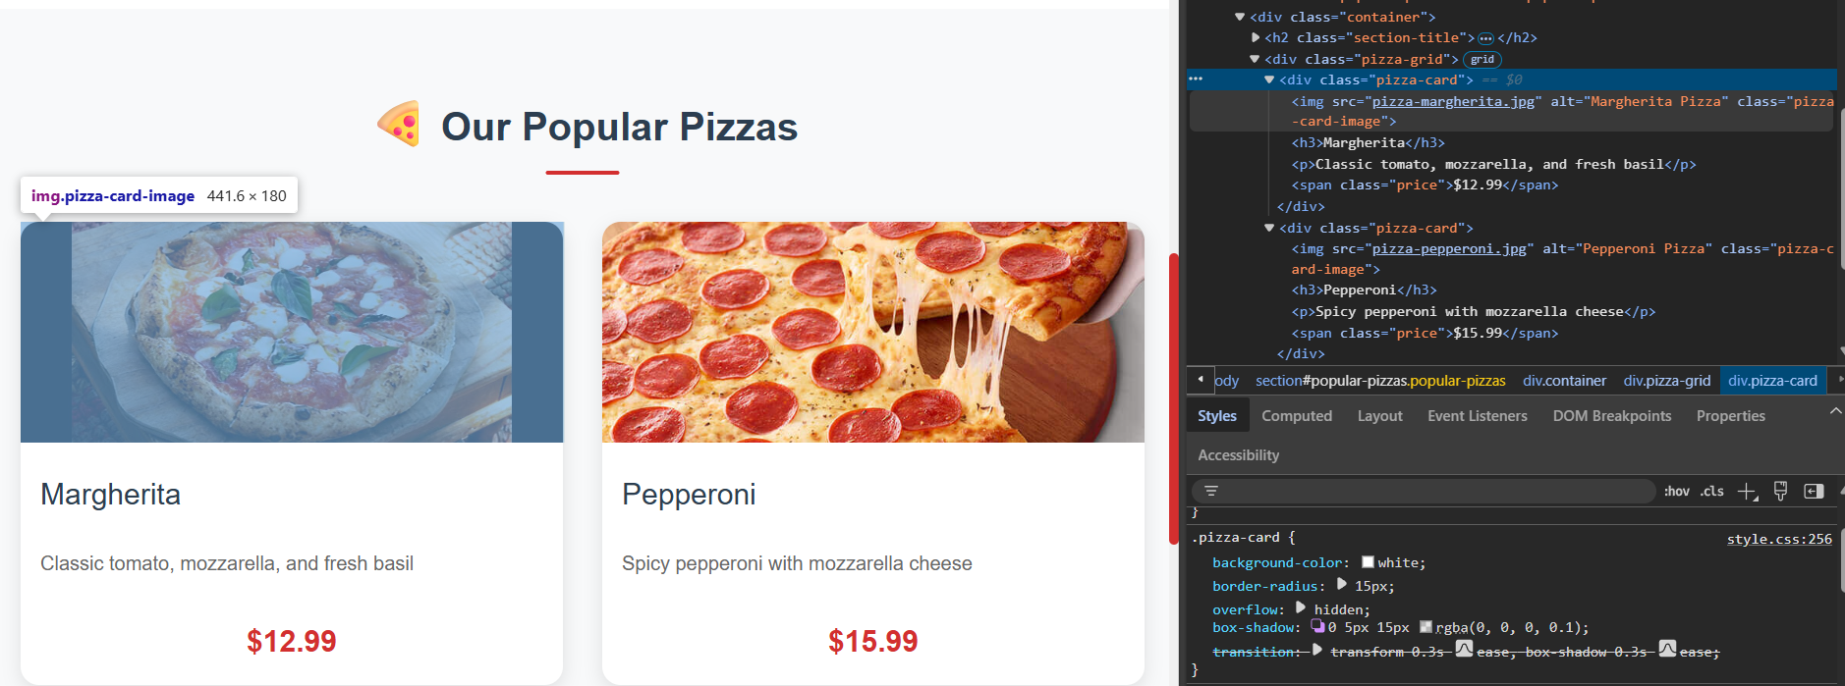

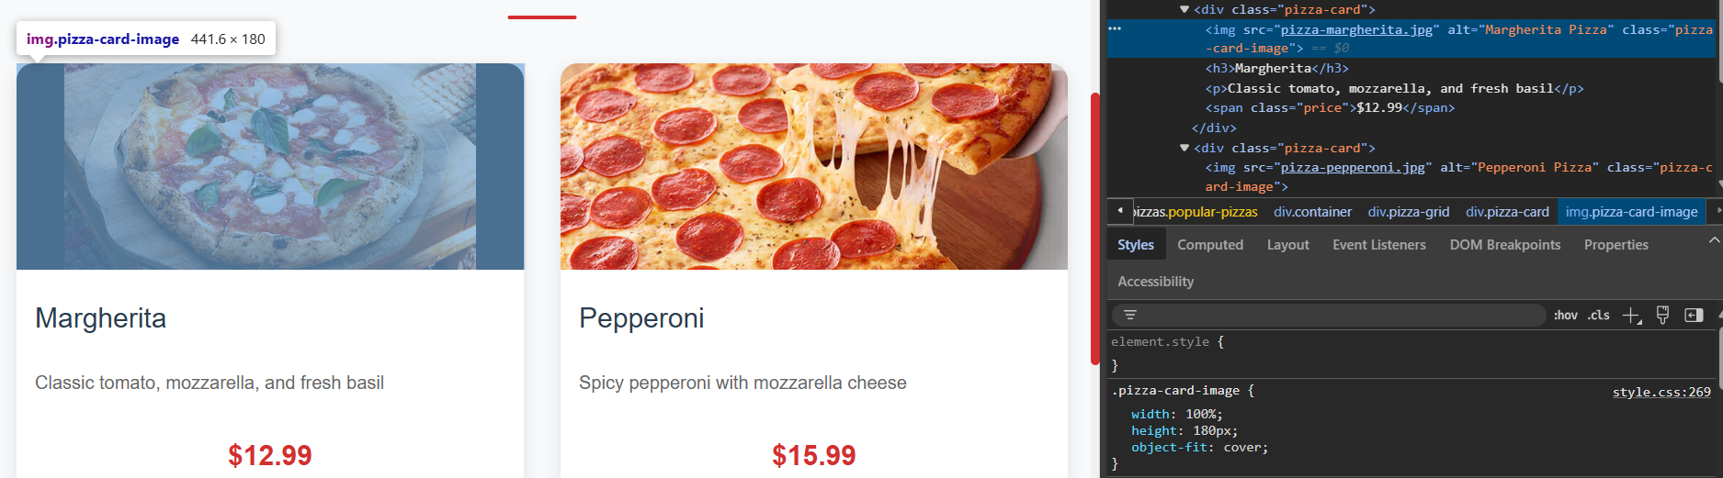

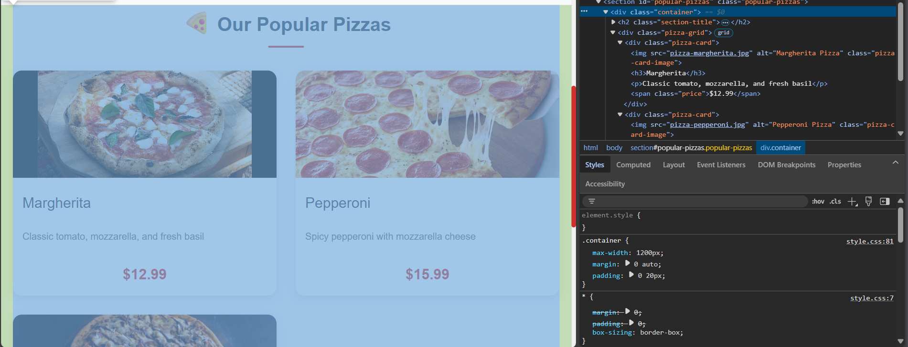

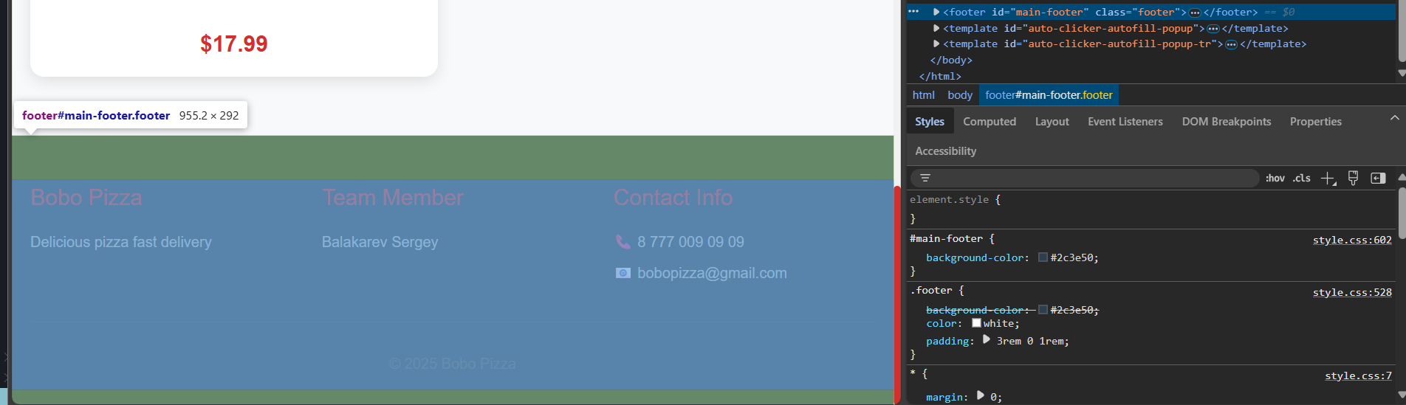

## Step 6. Navigation Menu

Styled nav bar with padding, spacing, background, and hover effects using descendant selectors.

Screenshot:

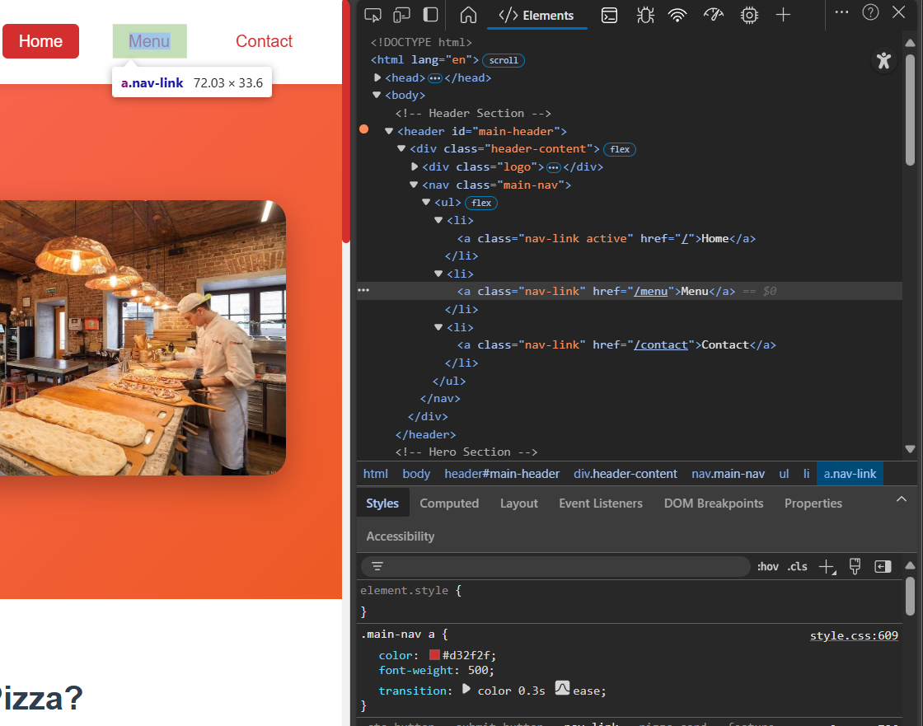

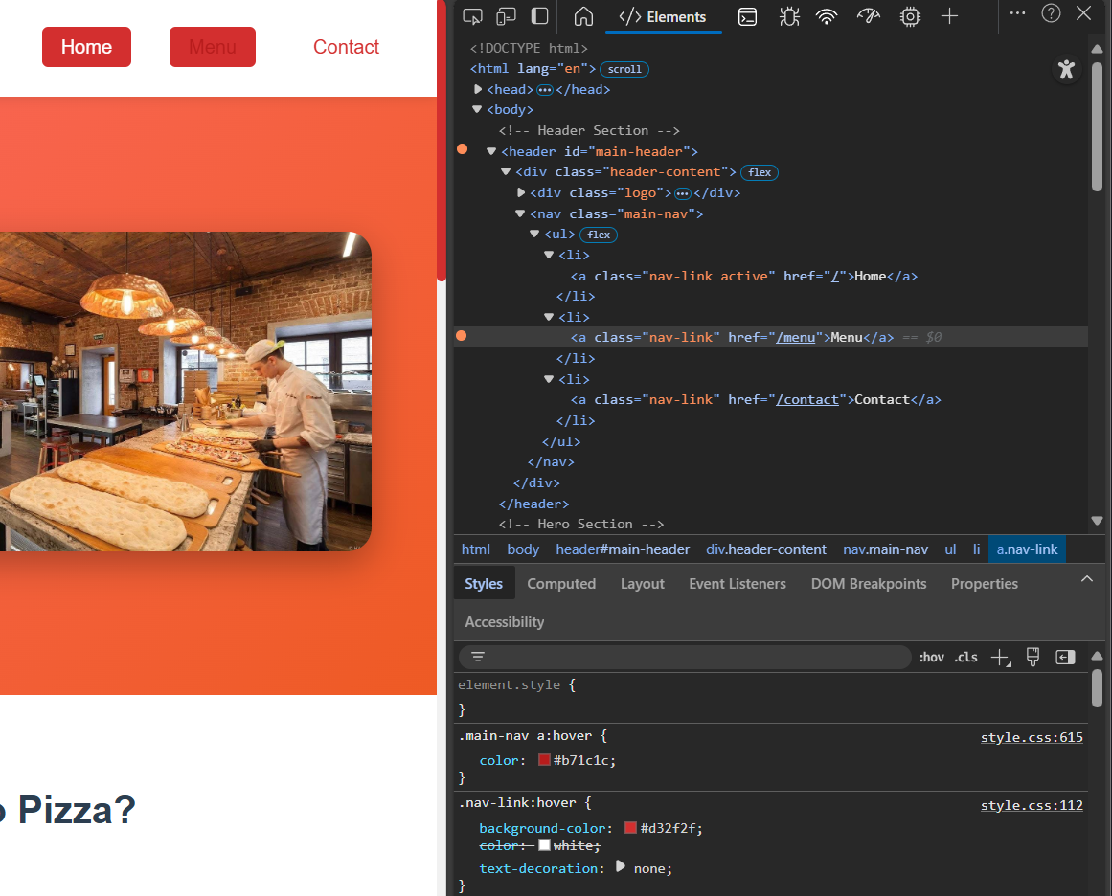

## Step 7. Image Styling

Resized images and made one circular using border-radius: 50%.

Screenshot:

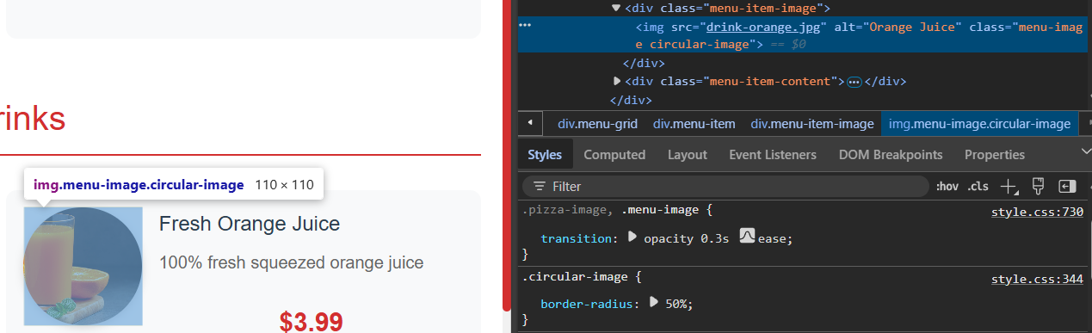

## Step 8. HTML Forms

Styled input, button, and textarea elements to match site design.

Screenshot:

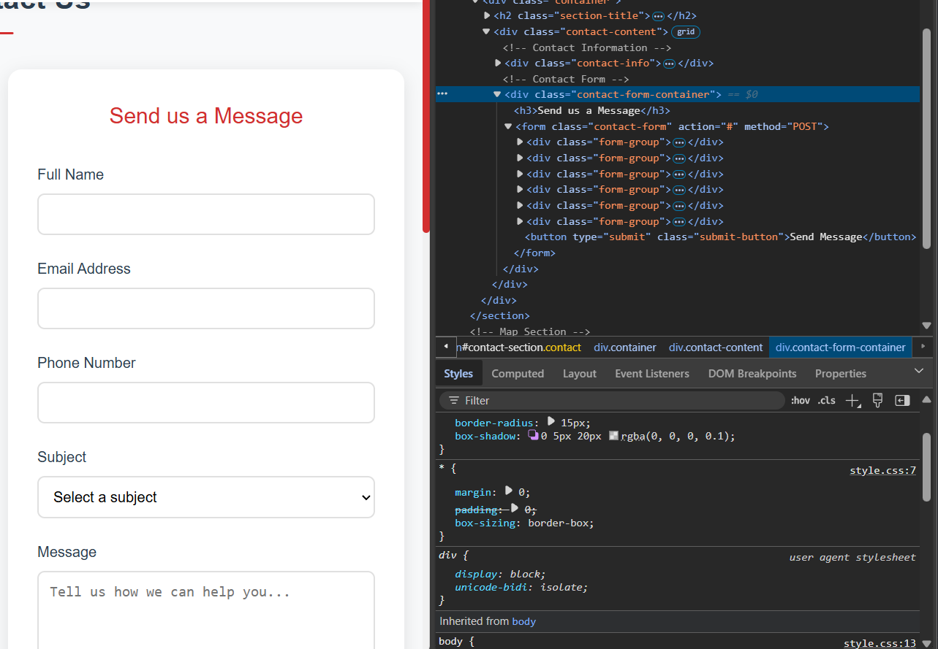

## Step 9. Advanced Styling (Optional Challenge)

Used pseudo-elements (::before, ::after) and transitions.

Screenshot:

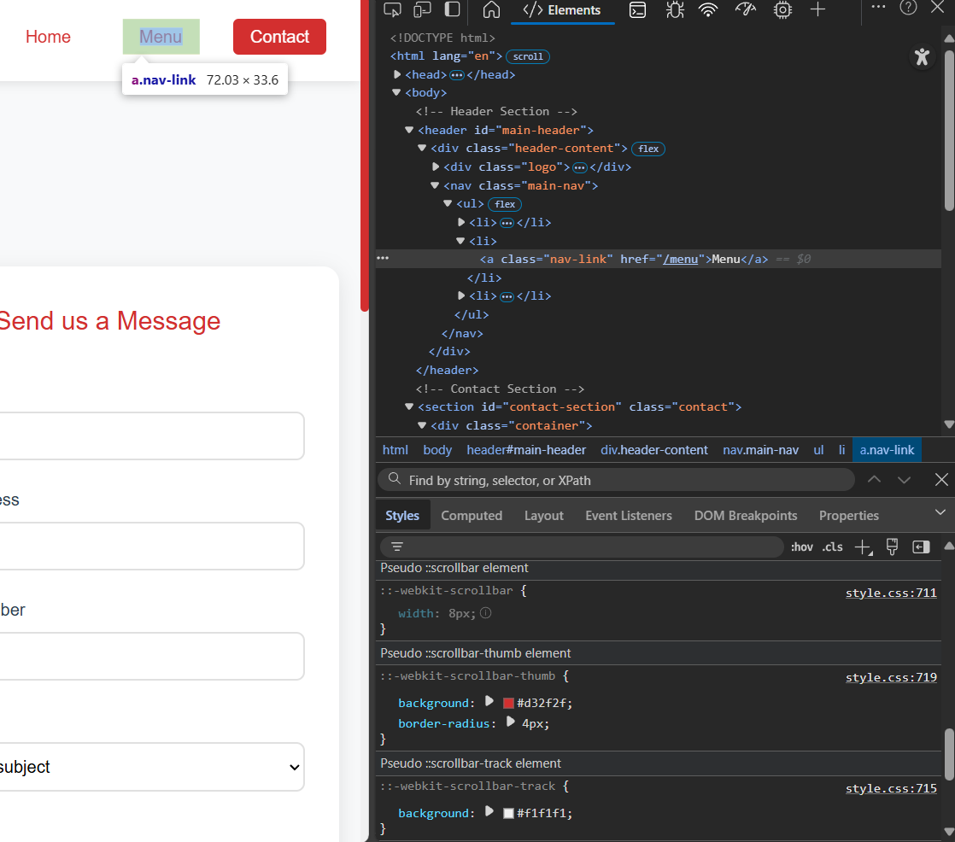

## Step 10. Publish Your Styled Website

Published via GitHub Pages or Netlify. Submitted live URL.

Screenshot:

[Bobo Pizza - Food Delivery](https://relaxed-truffle-7f30c8.netlify.app/)